How to run GIT Azure in the Computer Labs

Backing up your work is essential, and industry expects you to use version-control for your software. You can use GitHub for your remote repository, but for this tutorial we will use Azure Repo as you can access it with your Ulster University details.

Go to https://aex.dev.azure.com/ (this should bypass the unintuitive main Azure site)

You may have to login to Azure but it should be straightforward to use the Authentication Manager. At some stage you should see a link that says New project, click on it.

You’ll see the following. Please use the same name of the folder of the Laravel Project as the name of the Git Azure project and keep it private. You do not need to share it with anyone, including the lecturers.

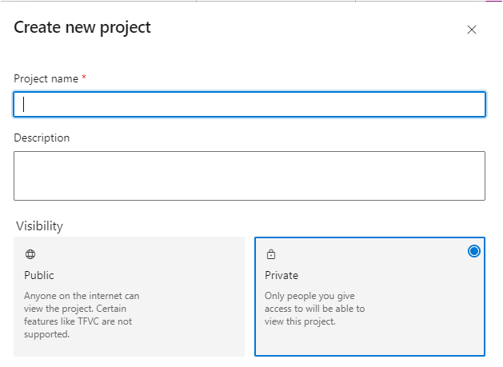It’s recommended that you call the Project the same name as the folder you built in Laravel, for example: example-app.

Then click on Repos, initially it will display two key Git commands you will need to use before the folder on C drive is available as shown here online:

Type cmd in the Windows search bar to bring up the Command Prompt
Create a folder for your Project. If it is a Laravel Herd project that exists then it would already be created through Herd. Using command line go to your folder.
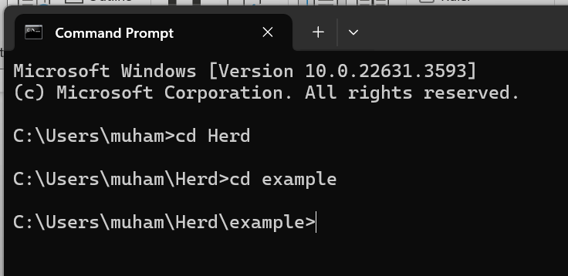

The lab PC’s will not remember your GIT credentials. (On a home PC the following only need to be set once as they are ‘global’. Your email address has to be the Ulster email address)
In your terminal, type the following:

git config --global user.name "Your Name"
git config --global user.email "yourname@ulster.ac.uk"

(Remember: At home you only need to do this the once, but in the Lab you will need to do this every time you log in to the computer)

The following command sets a hidden folder .git to maintain the changes.

git init

This sets up an empty repository in your directory. Now type

git add -A

The git add command will add all your changes and set them up for a commit.

Now type a useful message to set up the first version retained in the local repository
git commit -m "Set up first Web App"

Now, it's time to connect your computer to Azure DevOps to place a copy of the local repository into the cloud. This will allow you to download the repository to either your home PC or to the Lab PC.

Go to the Files-Repos page on your Azure DevOps project and you will see two git commands in the Push an existing repository from command line section.
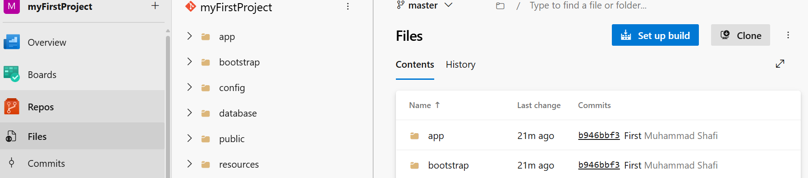

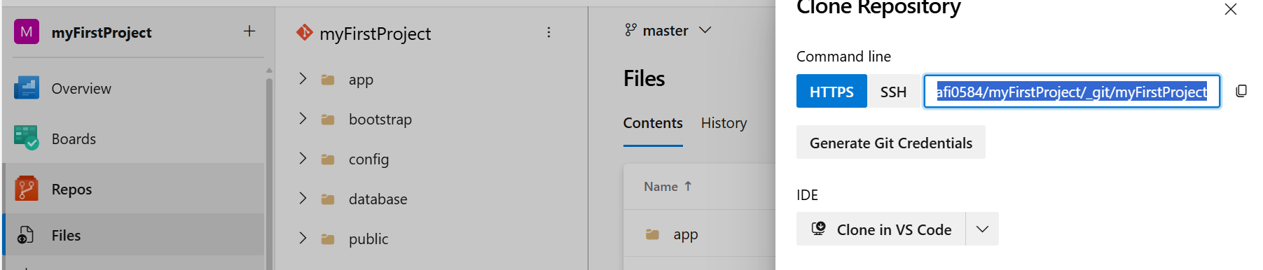

They will be similar to the following and in turn you should copy each one to the clipboard and paste to the cmd prompt and press Enter:

git remote add origin YourNameURL/example-app.git/example-app

Then your files will be pushed to the remote repo.
git push -u origin --all

The YourNameURL should match with the email address of your Ulster account.

You will be prompted to sign into the Git Credential Manager to authenticate and this is connected to the Multi Factor Authenticator App you use to log in to BBU and the Portal.
On a home PC the authentication is different, and you will need the long string password from the repo:

Note: It is not your Portal password.
Here is a example use of push, but your folder will be the Herd Project folder:
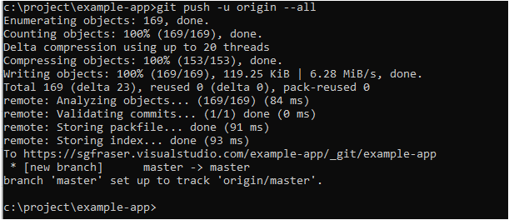

If you refresh the Repos view, you should get something resembling this:
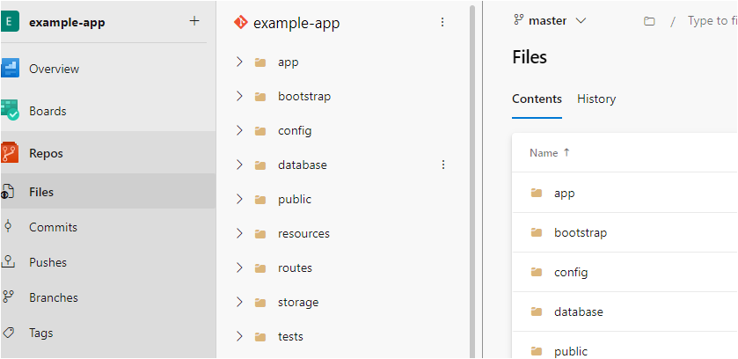

Working from your remote repository and re-instating a project to a Local Folder

Exit out of the Visual Studio terminals – CTRL + C and exit where applicable. And shut down Visual Studio Code.

Type cmd in the Windows search bar to bring up the Command Prompt and navigate to the Herd directory with the following command
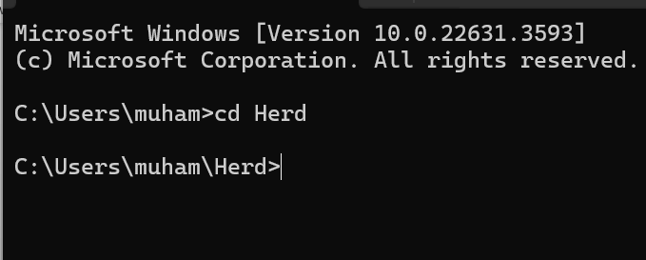
Create a new directory. We will call it test with the following command
mkdir test
And navigate to it
cd test
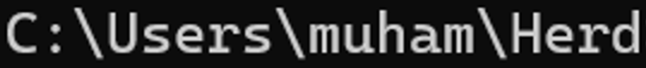\test

In the Repos section of your Project on the Azure Repos site, click on Clone and copy the Git command

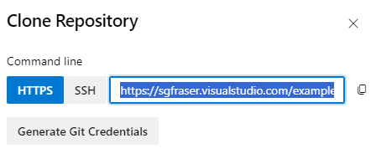

Click the Generate Git Credentials and take a note of the username and password (These may be required for lab use and you should match them by setting the git config user.name and user.email values).

Return to the Command Line and run the Git command git clone with the command line you copied i.e. something like this

git clone YourNameURL/example-app.git/example-app

The Git Credential Manager may ask you for your Ulster details. But you should get something like this by the end.

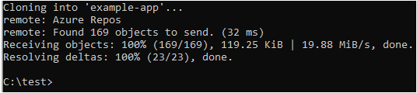

We will have to install all the dependencies of the project, i.e. all the files you would not want to waste the storage space retaining for the vendor and node_module folders, but that can be downloaded by running two commands. This will install all the Laravel environment, along with other packages needed to start your application.

Do the following for any Azure/Git Hub repo after you clone it to your local PC and it is located in the Herd folder and you are in the new sub-folder you created.
1. Run composer install command to generate dependencies in the vendor folder (make sure you are in the Project’s folder for the install to work)
2. change .env.example to .env (If this project is only for you and not being public or shared with others, then you can modify the .gitignore file to make sure a copy of your own .env is retained in the repo in the cloud.) 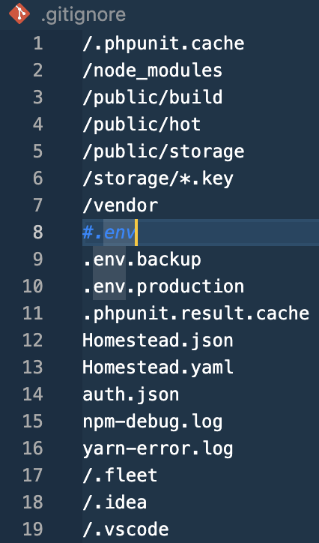
3. run php artisan key:generate command
4. run php artisan migrate to create empty database
5. Optional: run php artisan migrate:fresh --seed (Later stage when you have created the seed files to initialise your dB.)
Example: Add more text to the welcome.blade.php file and then commit the changes in the Windows Command Prompt
git add –A
git commit –m “added some text”
A warning may appear here, you can ignore it
git push origin master
Go to the Repos area on your Project and note that the second commit has taken place.
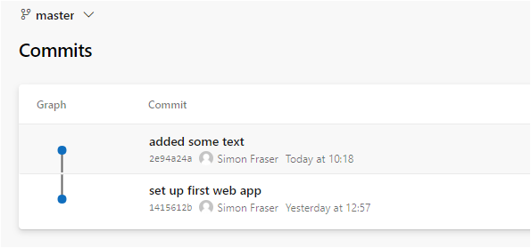
If you click on the commit, you’ll see the changes you made.
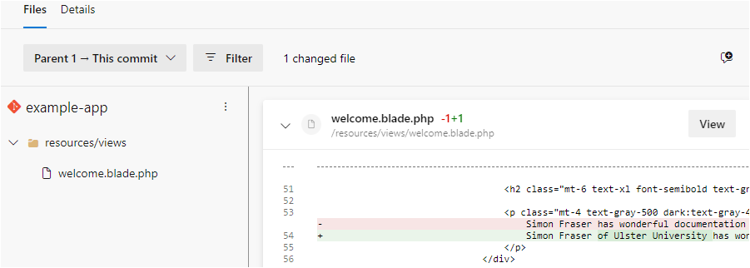

And that’s you. You did it. Don’t forget to close down the example-app project on your VS Code terminals – CTRL +C and exit where applicable.
For you to do as the Mini Challenge
- Create a new repo called Wk3PracticalTest – this is initially empty, but gives you the details that you will sync with step 2.
- Create a new Herd application on your local PC called Wk3PracticalTest
- Run your application in the browser to see if it works
- Using the files you retained from Week 1&2, add them to the correct places in the new Wk3PracticalTest project. For example, the components and view folders and the web.php
- Run your application to see if it works as it did last week.
- Commit your changes to the remote repository with a suitable message, such as “Added blade views”
- Push this change to your Wk3PracticalTest repo on Azure / Git Hub

- Clone the Wk3PracticalTest repo into a new differently named folder, such as, Wk3SecondExample, in the Herd folder
- Try to run the application in the new folder
You will have to run the steps to add the vendor files using composer install and the steps as you are not using Herd to initialise the project.
(Do a file comparison before and after you run the composer command and there should be a clear difference in the folder size. A Laravel project is around 550kb initially, but after the composer adds the dependencies this will go to 51Mb. This is part of the reason that storing all the Laravel project to a non-version control place such as OneDrive is not a good idea. The .gitignore is a key file in controlling those files that are or are not retained in the repo in the cloud.)

